**Bangladesh University of Engineering and Technology**



|  |
| --- |
| CE 404 |
| **Capstone Project**  **Structural Analysis**  **(Analysis of Model)** |

**Comprehensive Redevelopment Project for Mohammadpur Government High School: Enhancing Academic Infrastructure and Sustainability**

|  |  |
| --- | --- |
| **Student ID & Name** | :**1804165 - Shoeb Ahmad Tanim**  **1804173 - SM Nahian Al Wasi (GL)**  **1804176 – Abu Naser Khan**  **1804177 - Muhammed Yeasin Arafat**  **1804179 - Shamim Azad Bakul**  **1804180 – Samiha Tasneem (DGL)** |
| **Level/Term/Department** | : 4/2/ Civil Engineering |
| **Section/Group** | : C2/3 |

Submitted to

|  |  |
| --- | --- |
| **Dr. Hasib Mohammed Ahsan**  Professor  Dept. of Civil Engineering, BUET | **Dr. Sarwar Jahan Md. Yasin**  Professor  Dept. of Civil Engineering, BUET |
| **Dr. Sheikh Mokhlesur Rahman**  Assistant Professor  Dept. of Civil Engineering, BUET | **Dr. Rupak Mutsuddy**  Assistant Professor  Dept. of Civil Engineering, BUET |

**Introduction**

This detailed report aims to provide a comprehensive analysis of the Mohammadpur Government High School redevelopment project. The primary objective is to offer an in-depth understanding of the proposed enhancements, emphasizing modernization, safety, and environmental responsibility.

The project integrates cutting-edge elements adhering to green building principles, aligning with the Bangladesh National Building Code (BNBC) standards. Structural engineering assessments ensure earthquake resilience, surpassing local building codes for heightened safety. Advanced construction methodologies, such as Building Information Modeling (BIM), enhance precision and efficiency. Sustainable practices, including waste management and water conservation, are seamlessly integrated, reflecting a commitment to environmental responsibility.

The technical design meticulously considers climate change impacts, with a Climate Vulnerability Assessment informing recommendations. Building resilience focuses on structural improvements, enhanced drainage systems, and comprehensive emergency preparedness.

Modern facilities integration emphasizes energy efficiency, smart building technologies, digital learning infrastructure, and accessibility. The project's commitment to safety and sustainability, aligned with BNBC codes, ensures its long-term viability.

In summary, this report serves as a foundational document, providing a detailed blueprint for the Mohammadpur Government High School redevelopment project. It outlines the key components, design principles, and considerations that collectively contribute to the project's success and longevity.

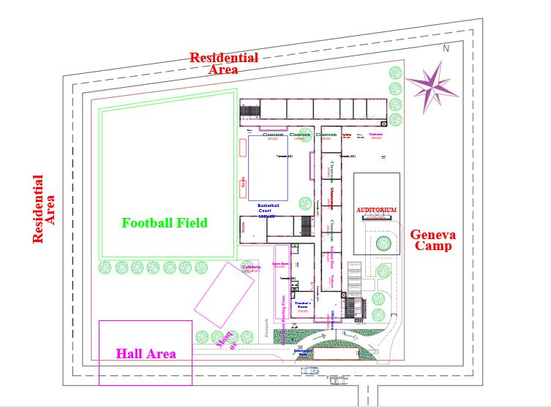

Fig: Masterplan of Mohammadpur Government High School Redevelopment Project

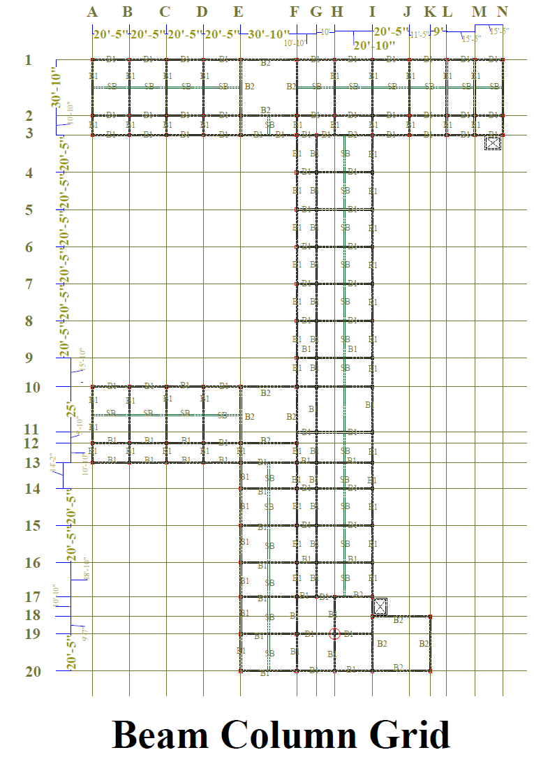

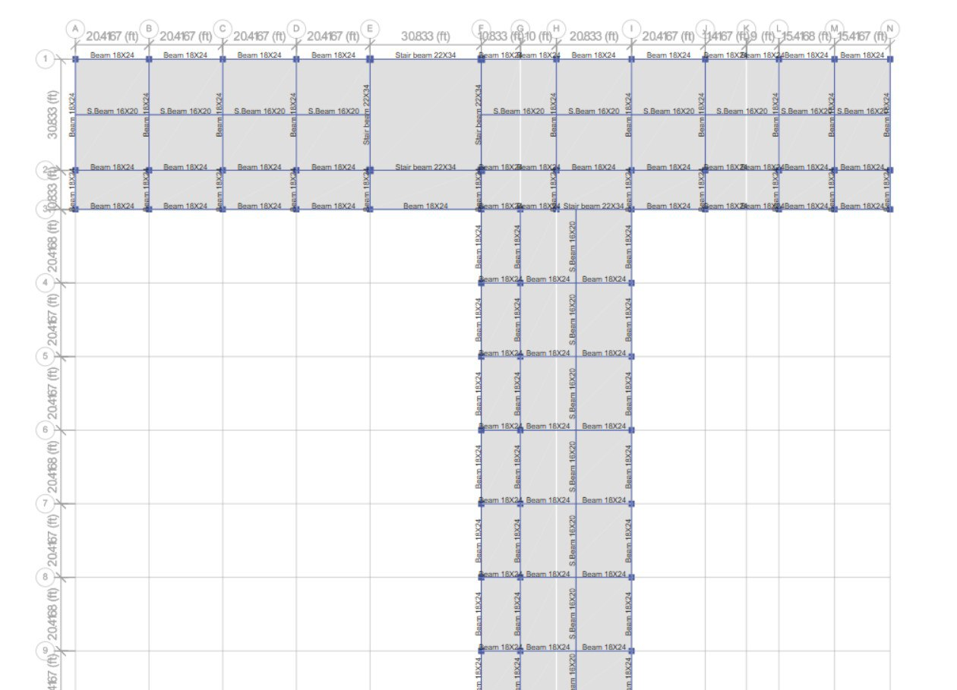

Fig: First Half of the Building with Beam Names

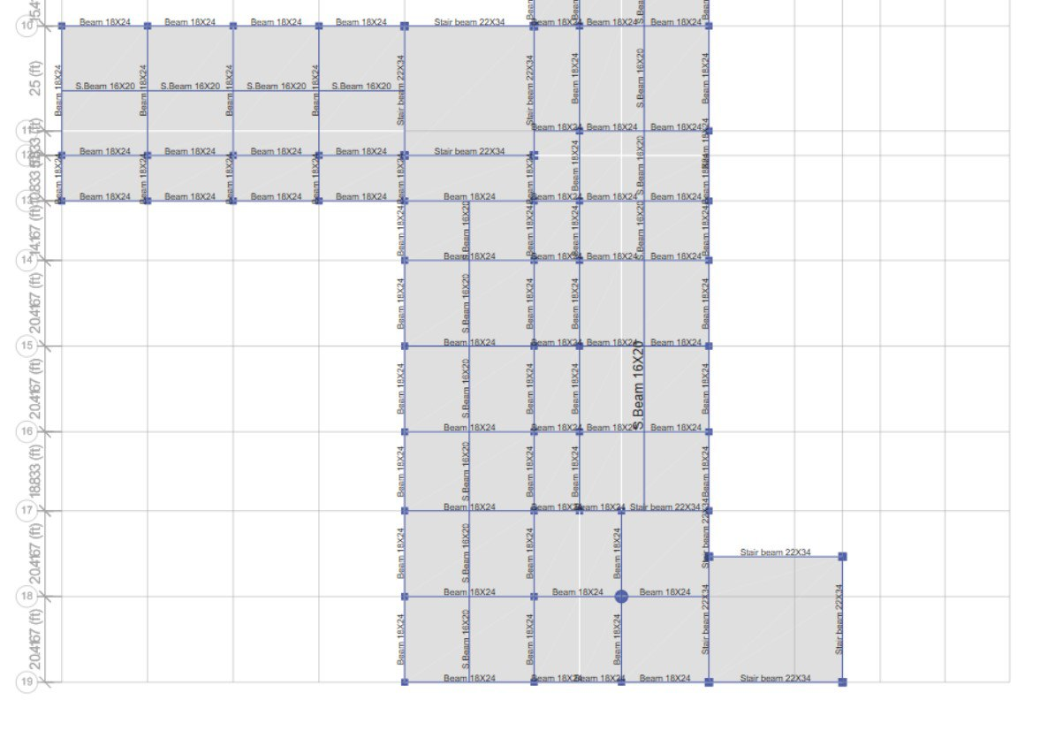

Fig: Second Half of the Building with Beam Names

**Design Considerations and Codes**

**Structural Design Considerations and Codes:**

The project involved major structural design of the academic building. For the building we have chosen RCC structure.

BNBC 2020 Part VI Chapter 1, Chapter 2:

Sway limitation: The overall sway (horizontal deflection) at the top level of the building or structure due to wind loading shall not exceed - 500 times the total height of the building above ground.

Storey drift, Δ: For loads other than earthquake loads, shall be limited as follows: Δ ≤ 0.005ℎ for T< 0.7 second Δ ≤ 0.004ℎ for T ≥ 0.7 second Δ ≤ 0.0025ℎ for unreinforced masonry structure.

Stiffness Irregularity - Soft Storey: A soft storey is one in which the lateral stiffness is less than 70% of that in the storey above or less than 80% of the average lateral stiffness of the three storeys above irregularity. An extreme soft storey is defined where its lateral stiffness is less than 60% of that in the storey above or less than 70% of the average lateral stiffness of the three storeys above.

**Load Combination for Serviceability**

Serviceability limit states of buildings and structures shall be checked for the load combinations set forth in this Section as well as mentioned elsewhere in this Code. For serviceability limit states involving visually objectionable deformations, repairable cracking or other damage to interior finishes, and other short-term effects, the suggested load combinations for checking vertical deflection due to gravity load is

1. D + L

For serviceability limit states involving creep, settlement, or similar long-term or permanent effects, the suggested load combination is:

2. D + 0.5L

The dead load effect, D, used in applying combinations 1 and 2 above may be that portion of dead load that occurs following attachment of nonstructural elements. In applying combination 2 above to account for long term creep effect, the immediate (e.g. elastic) deflection may be multiplied by a creep factor ranging from 1.5 to 2.0. Serviceability against gravity loads (vertical deflections) shall be checked against the limits set forth in Sec 1.2.5 Chapter 1 of this Part as well as mentioned elsewhere in this Code.

For serviceability limit state against lateral deflection of buildings and structures due to wind effect, the following combination shall be used:

3. D + 0.5L + 0.7W

**Foundation Design Considerations and Codes:**

For this project we have chosen isolated shallow foundation system for the academic building.

**DESIGN PARAMETERS AND THEIR VALUES:**

**Structural Design Parameters and Values:**

Choice of Structural System:

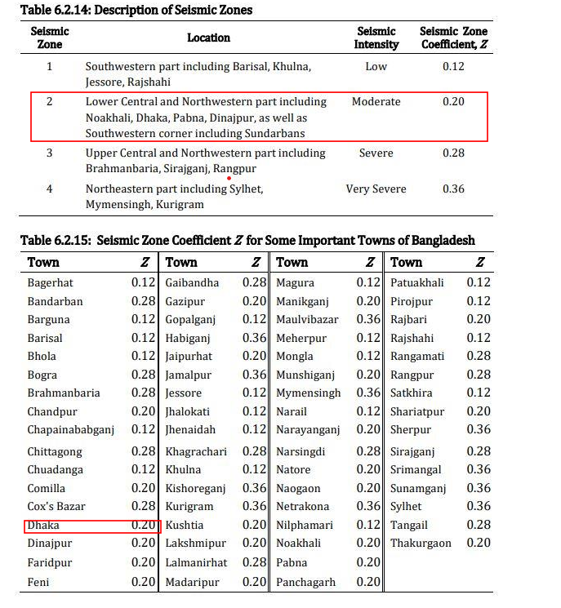

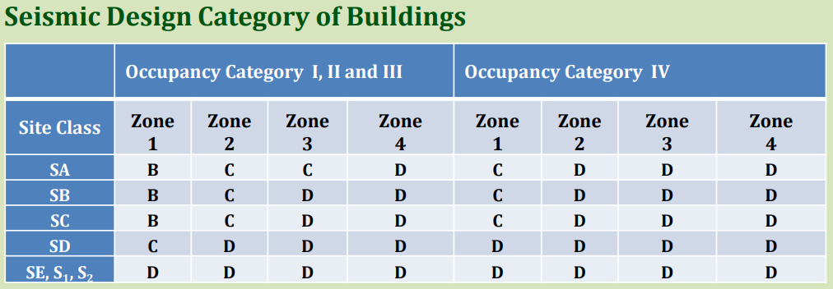





**Location:** Mohammadpur, Dhaka

**Avg SPT value =** 18

**Allowable soil pressure=** 6.34 ksf

**fc=**3.5ksi **fy=**60ksi

**Footing type=** Isolated Shallow Foundation

using

1. square

2. rectangular

3. combine

**Seismic zone:** Zone II; Site Class: SC

**Occupancy Category:** Academic Building: III; Auditorium: III

**Seismic Design Category:** SC

**Choice of Structural System:**

**For Academic Building:**

Special Reinforced Concrete Moment Frame (No Shear Wall)

**For Auditorium:**

Special Reinforced Concrete Moment Frame (No Shear Wall)

**Choice of Materials:**

RCC Academic Building

Concrete Strength, fc’= 3.5 ksi

Reinforcement Strength fy= 60 ksi

**Assigned Loadings:**

**RCC Academic Building:**

Floor Finish (cement Plaster 20mm thickness)=25 psf

Partition Wall (8” burnt clay brick masonry with cement plaster)= 100 psf

Live Load : 45psf

Stairs and exit way = 100 psf

Corridor: 85 psf

Note: All the values are provided in kn/m2 in BNBC 2020

Source: *BNBC Chapter VI table 6.2.1, 6.2.2, 6.2.3*

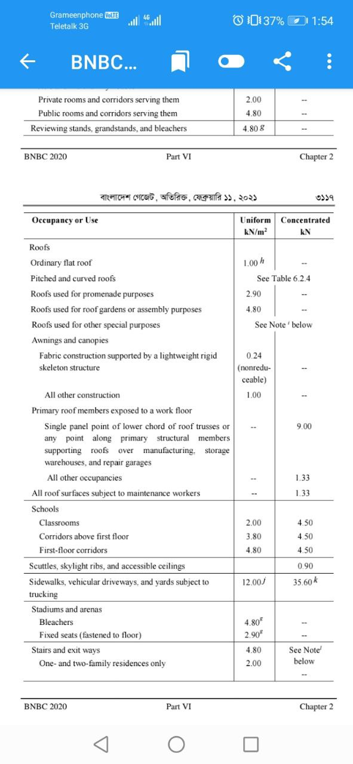



**MODELLING AND ANALYSIS**

**Academic Building**

**Structural Analysis:**

**Story Definition:**

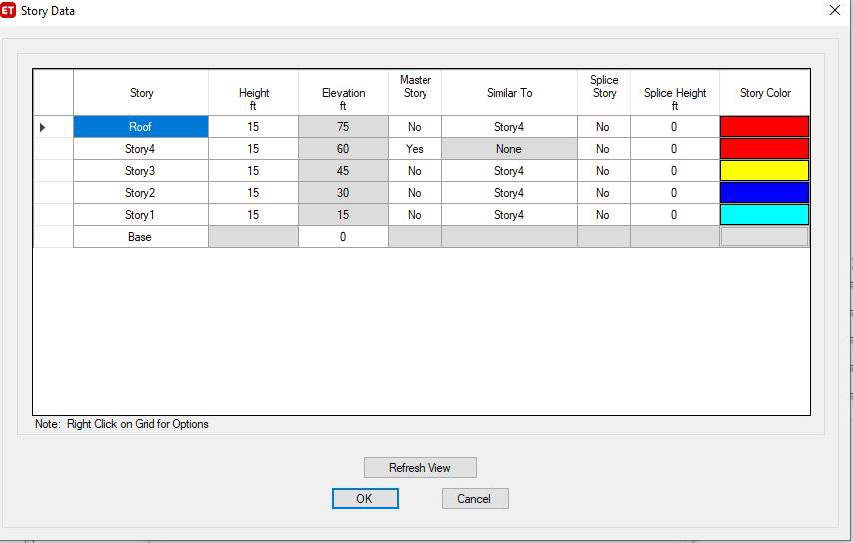

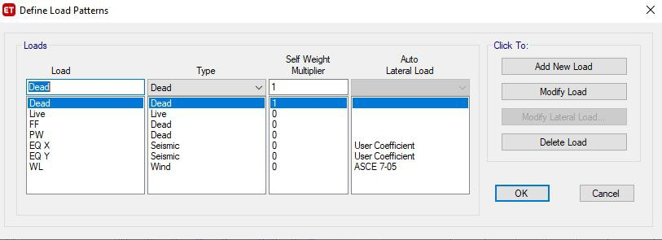**Load Pattern:**

**Frame Sections:**

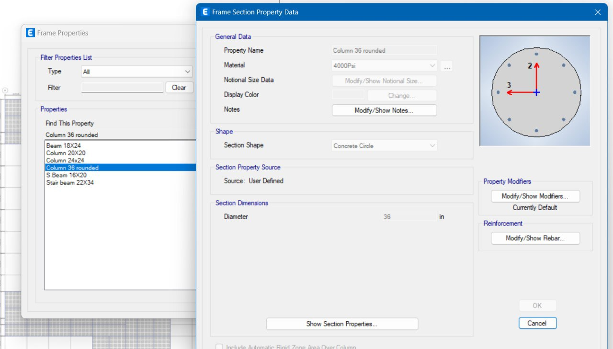

**Beam 18X24**

**Secondary Beam 16X20**

**Stair Beam 22X34**

**Column 20X20**

**Column 24X24**

**Column 36 rounded**

**Wind load pattern:**

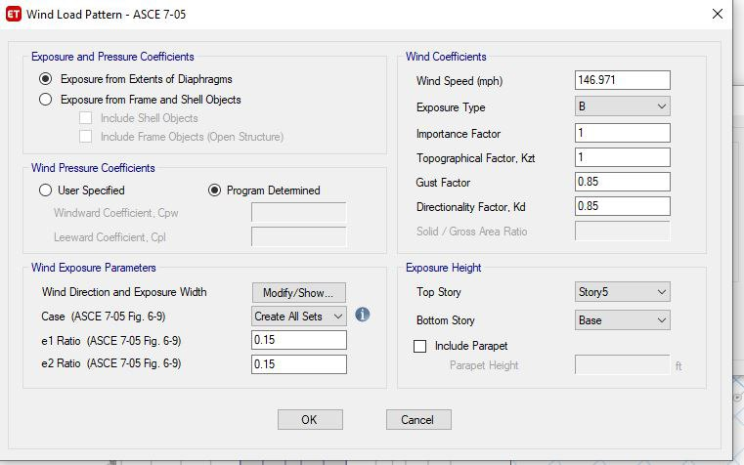

**Earthquake Load Pattern:**

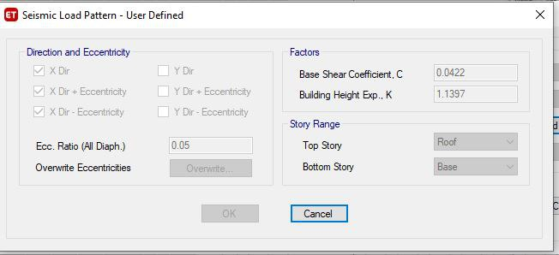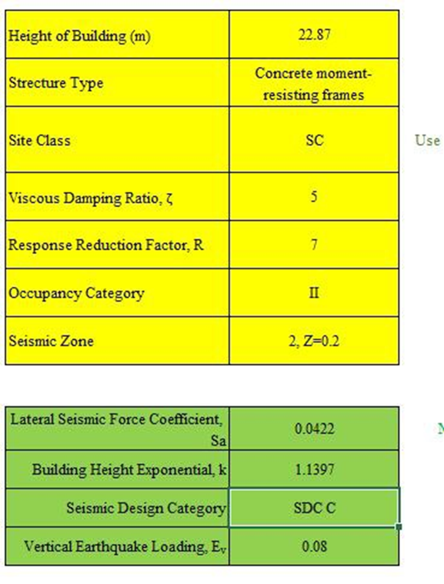

**Load Combination:**

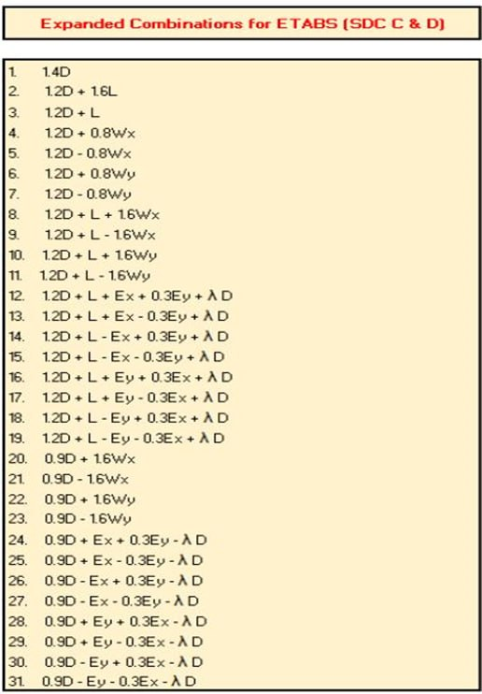

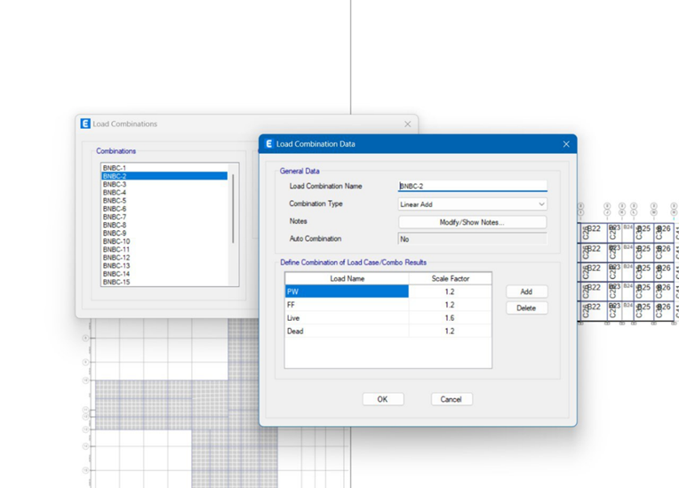

*Figure: Combinations in Etabs*

**Etabs Model of Academic Building:**

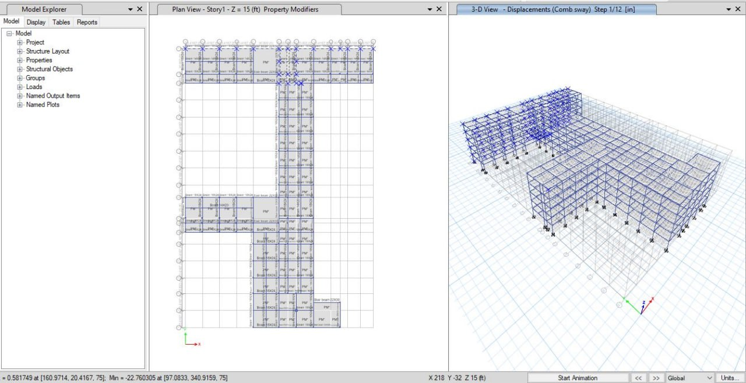

Model is Irregular shaped, so no definite length or width is mentioned.

Total grid length= 225.83 ft

Width= 356.33 ft

**Serviceability Check:**



Checks that are to be done:

1. Beam Deflection
2. Wind Sway 3.Wind Drift
3. Torsional Irregularity
4. Earthquake Drift

**Stiffness Modifiers for Service Condition Check:**

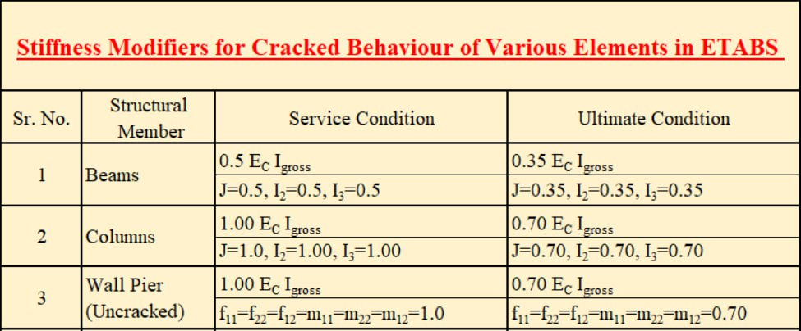

**Beam Deflection:** Combination: DL+LL

Limit= L/240=(20.417*12)/240=1.02”

(For 20.417 common span)

From ETABS maximum deflection=0.3307”<1.02” (okay)

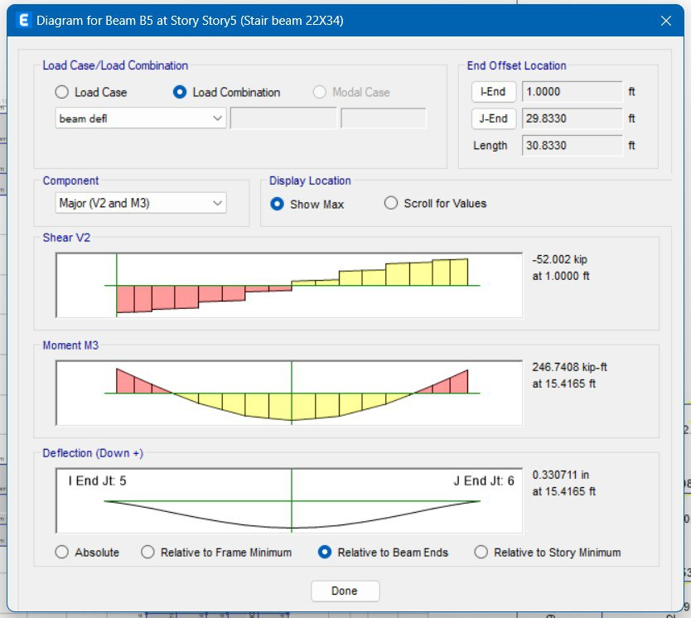

**Wind Sway:**

The overall sway (Horizontal Deflection) at the top level of the building or structure due to wind

loading shall not exceed 𝟏/𝟓𝟎𝟎 times the total height of the building above ground. (Source: BNBC Part VI; Section 1.5.6.2)

Δ ≤ 𝑯/𝟓𝟎𝟎

Here, H = Height of the building, 75 ft above ground

Load Combination: DL+0.5LL+0.7WL

Limit: H/500=75*12/500=1.8”

From ETABS maximum displacement=0.56”<1.8” (okay)

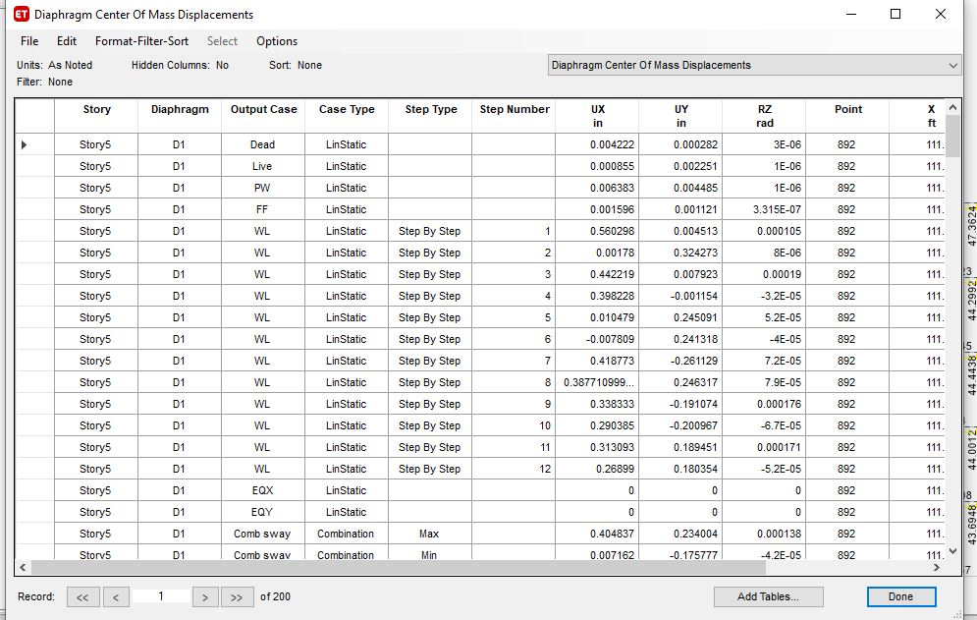

**Wind Drift**: Storey drift, ∆, for loads other than earthquake loads, shall be limited as follows:

1. ∆ ≤ 0.005ℎ for T < 0.7 second

2. ∆ ≤ 0.004ℎ for T≥ 0.7 second

3. ∆ ≤ 0.0025ℎ for unreinforced masonry structures. Where, ℎ = height of floor & T= Time Periods (Source: BNBC Part VI; Section 1.5.6.1)

For the main building, T= 0.779 sec (So, T < 0.7 second) Height of floor, H= 15 ft

Maximum Drift Limit= 0.004h= .004*75*12= 3.6’’

**Combination:** WL along X direction

Drift= 1.9’’<3.6’’ (OK)

Along Y direction,

Drift= 0.58<3.6’’

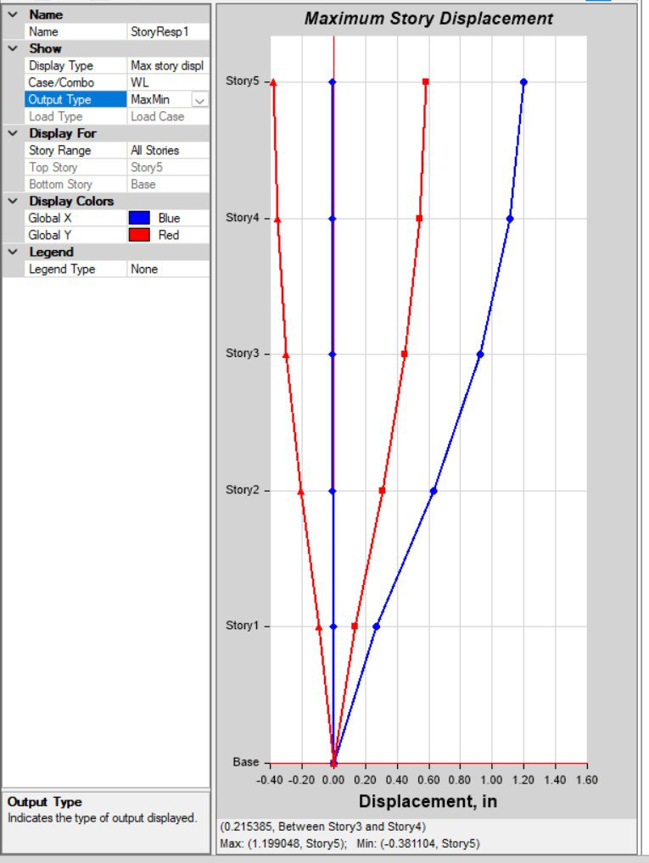

**Torsional irregularity:**

If ∆𝑚𝑎𝑥/∆𝑎𝑣𝑟𝑔> 1.2, then Normal Tortional Irregularity If ∆𝑚𝑎𝑥/∆𝑎𝑣𝑟𝑔> 1.4, then Extreme Tortional Irregularity Here,

∆𝑚𝑎𝑥 = Maximum Storey Drift

∆𝑎𝑣𝑟𝑔 =(∆𝑚𝑎𝑥+ ∆𝑚𝑖𝑛)/2

Combination: For Earthquake along x & y direction

Δmax =0

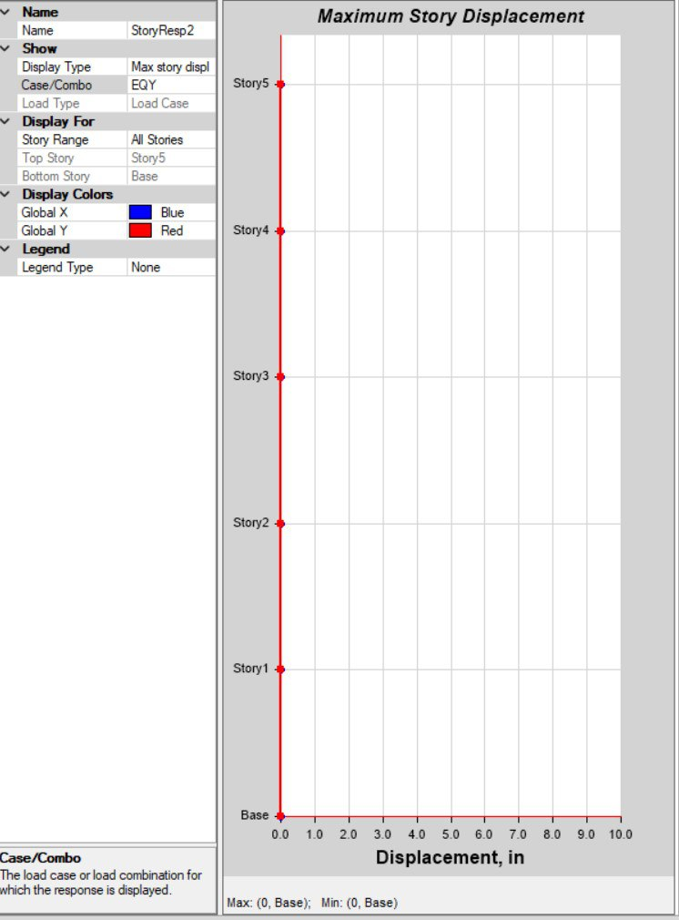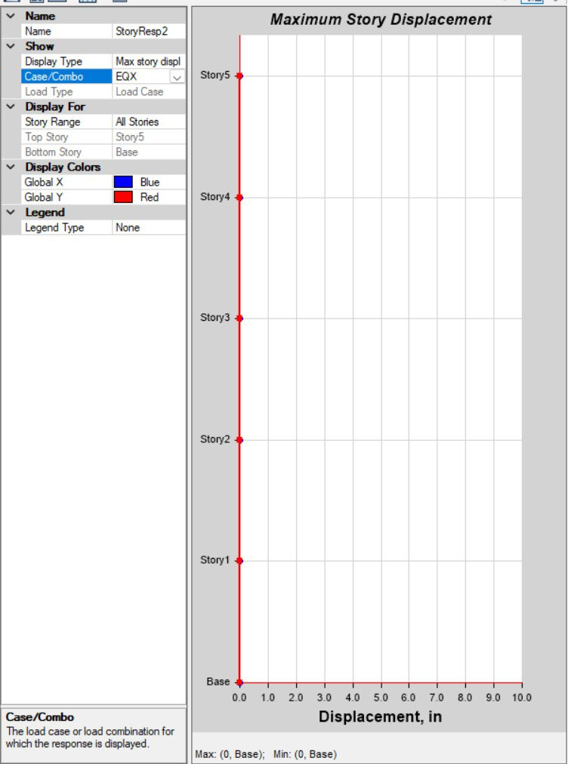

Thus, torsional irregularity check is not needed.

**Earthquake Drift:** No earthquake drift was detected.

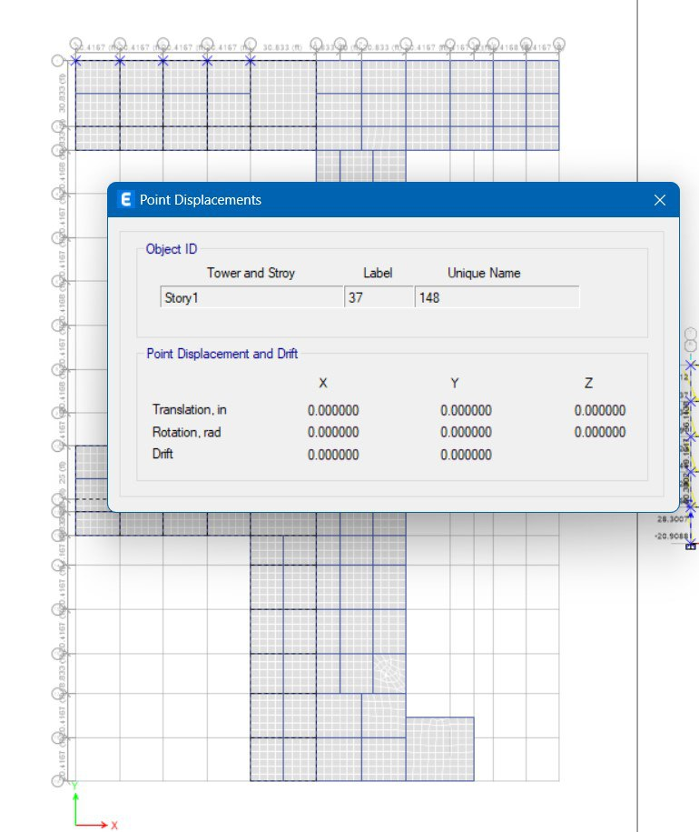

**Ultimate Check:**

ALL MEMBERS PASSED THE ULTIMATE CHECK

